**MODELLING EPIDEMICS**

**THROUGH SIR MODEL**

Prepared for

**Prof. Anushaya Mohapatra**

As a part of the course

Mathematical Modeling, MATH F420



Yashraaj Jatania 2022B4A70420G

**ABSTRACT**

In the realm of understanding infectious diseases and guiding public health strategies, epidemiological models are indispensable tools. One of the fundamental models in this domain is the Susceptible-Infectious-Recovered (SIR) model. Through the use of mathematical equations, it captures the dynamics between susceptible individuals, those who are infected, and those who have recovered and gained immunity. The aim is to examine the use of the SIR model and its importance in epidemiology. We will also be analyzing the application of this model through various epidemics and pandemics in history.

**INTRODUCTION**

* Epidemiological models, such as the Susceptible-Infectious-Recovered (SIR) model, play a crucial role in understanding and managing infectious diseases.
* Developed in the early 20th century, the SIR model has become a cornerstone in epidemiology for predicting the spread of diseases within populations. It divides the population into compartments based on their disease status and tracks transitions between these compartments over time.
* By incorporating factors such as transmission rates, population demographics, and intervention strategies, SIR models provide valuable insights into epidemic dynamics. These insights help public health officials make informed decisions regarding disease control measures, resource allocation, and outbreak management.
* As infectious diseases continue to pose significant threats to global health, the importance of SIR models in tracking epidemics and guiding public health responses remains paramount.
* By categorizing individuals into distinct compartments based on their disease status, SIR models enable researchers and public health officials to simulate and predict epidemic dynamics. These models capture the interplay between susceptible individuals, those who are infectious, and those who have recovered and gained immunity, providing insights into transmission rates, epidemic peaks, and the effectiveness of intervention strategies such as vaccination and social distancing measures.

**ASSUMPTIONS**

* The number of deaths is negligible concerning the total population
* No Demographic Structure: The model does not account for variations in age, gender, or other demographic factors within the population.
* A homogeneous mixing of the population is assumed.
* We ignore births and deaths in this model and assume the disease is spread by contact.
* No skipping from S to R and no recovery term from I to S, No one joins the susceptible group.
* Contacts of an individual with the rest of the population also follow a uniform distribution.
* The susceptible population gets infected at a rate proportional to the size of the susceptible population (S) and infected population (I) (proportionality constant β > 0)

**MODELLING OF SIR MODEL**

The governing equations of the SIR model are

$$\frac{dS\left(t\right)}{dt}= -βSI$$



$\frac{dR(t)}{dt}= γI$

Here β is the interaction rate and γ is the recovery rate

Another way of interpreting the model can be that the total population remains unchanged i.e. Integrating both sides gives us S + I + R = N where N is the total population. Instead of the actual population, we can also use the ratios of S, I, and R for the total population to plot on a scale of 0 to 1

**GRAPHING THE SIR MODEL IN MATLAB**

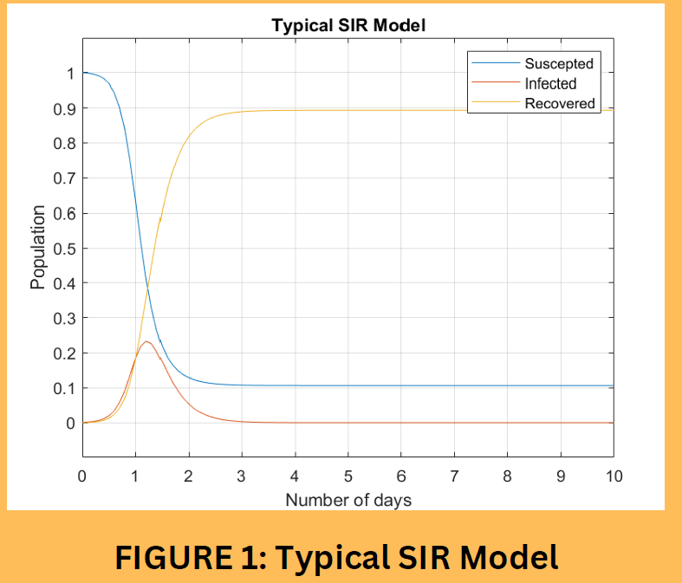

Figure 1 depicts the spread of a new disease in a completely susceptible population, considering So ≈ 1 and Io, Ro ≪ 1. The exponential growth from the second differential equation with these approximations becomes:

$$\frac{dI(t)}{dt}=(β-ϒ)I(t)$$

whose approximate solution is

**I(t) = e(β-ϒ)t**

If β < γ , the infectious population will decrease since each infected individual passes the disease to less than 1 person on average. But if >0, the number of infected people will double over each time interval of length:

**Td =**

which is known as the doubling time. This exponential growth will eventually slow as the susceptible population S decreases. The peak is reached in the infectious population when I′(t) = 0, i.e. when βS=γ.

**Equilibrium Points**

Since S + I + R = N, R(to) can be determined by the values of S(to) and I(to) at any given time to. For convenience, we can convert this 3-D system to 2-D.

$\frac{dS(t)}{dt}$ = −βSI = f(S, I)

$\frac{dI(t)}{dt}$ = βSI − γI = g(S,I)

At the equilibrium points, f(S*, I*) = g(S*, I*) = 0

On solving the equations, we get the equilibrium point for the system (S*, I*) = (S, 0)

**Asymptotic Stability**

Now to check the stability of the equilibrium points, we find the Jacobian matrix of f(S,I) and g(S,I).

J = $\left[\begin{matrix}\frac{∂f}{∂s} & \frac{∂f}{∂I} \\ \frac{∂g}{∂s} & \frac{∂g}{∂I}\end{matrix}\right]$

= $\left[\begin{matrix}-βI & -βS \\ βI & βS-ϒ\end{matrix}\right]$

J(S*,I*) =

**STABILITY ANALYSIS**

Eigenvalues of this matrix are λ1 = 0, λ2 = βS−γ and eigenvectors are :

V1  = , and V2 =

Let us consider the disease-free equilibrium point: S =N, I =0, R =0. We can see from equation (1) that this point is stable only if:

N ≤ β/γ

N ≤ $\frac{1}{\frac{β}{ϒ}}$

β/γ is known as the reproduction number and is denoted by Ro

If RO ≤

the equilibrium is stable and the epidemic won’t spread.

If RO ≥

the equilibrium is unstable and the epidemic will spread further

**GRAPHING THE SIR MODEL IN MATLAB**

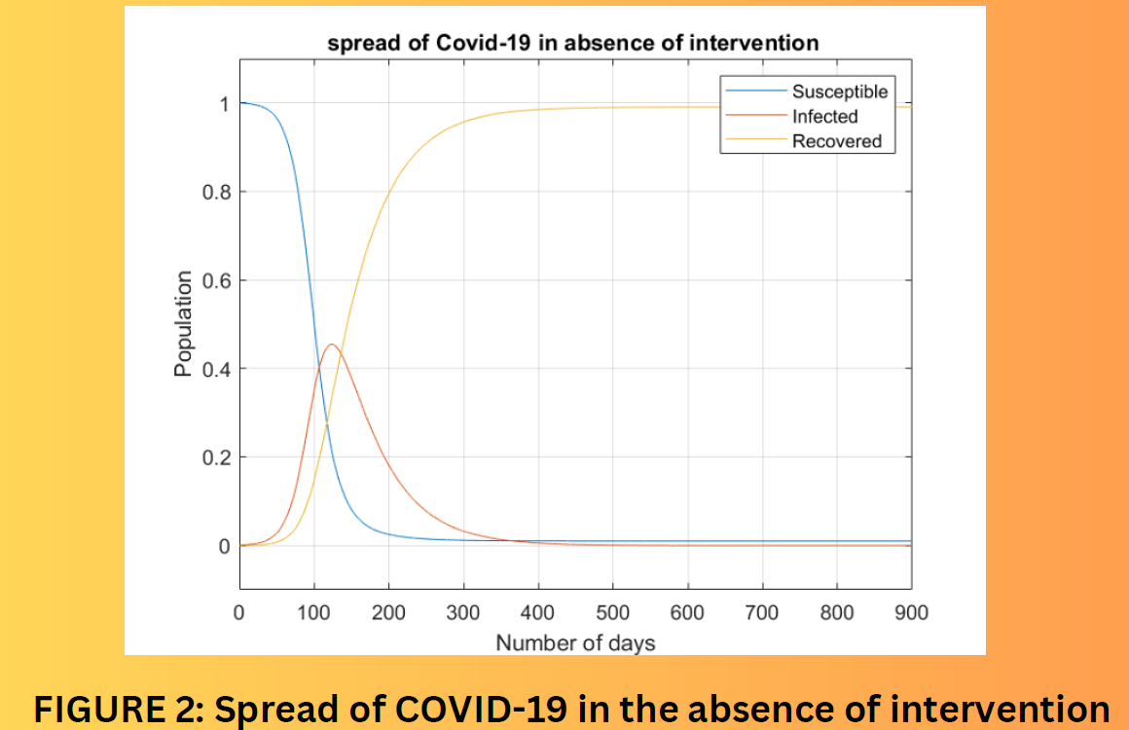

FIGURE 2: Spread of COVID-19 in the absence of intervention

**Intervention**

* We assume that the infection rate β is constant over time when using the basic SIR model.
* The public and the government can implement strategies that lower the infection rate. The government of India had imposed a nationwide lockdown for 21 days. The rate of infection is also somewhat reduced by frequent use of sanitizer and masks.

Let the fraction of contact prevention through such intervention is q where q is independent of time. This can be included in the differential equations as

$$\frac{dS\left(t\right)}{dt}= -\left(1-q\left(t\right)\right)βSI$$

$\frac{dI\left(t\right)}{dt}=\left(1-q\left(t\right)\right)βSI- ϒ$

$\frac{dR\left(t\right)}{dt}= ϒI$

Quite clearly, if there is no intervention, q= 0 i.e. there is no change in effective β. The ideal case of identifying and isolating each infected person would result in q = 1.

Since S + I + R = N, R(tO) can be determined by the values of S(tO) and I(tO) at any given time to. For convenience, we can convert this 3-D system to 2-D.

$$\frac{dS\left(t\right)}{dt}= -\left(1-q\left(t\right)\right)βSI=0$$

$\frac{dI(t)}{dt}=\left(1-q\left(t\right)\right)βSI- ϒI=0$

where $\frac{dS\left(t\right)}{dt}=f\left(S*, I*\right)$

$\frac{dI\left(t\right)}{dt}=g\left(S*,I*\right)$

Let's calculate the eigenvalues now, we get

J(S*,I*) = J(S*,0) = $\left[\begin{matrix}0 & -(1-q\left(t\right))βS \\ 0 & \left(1-q\left(t\right)\right)βS-ϒ\end{matrix}\right]$

Eigenvalues of this matrix are λ1 = 0, and λ2 = (1-q)βS−γ and eigen vectors are:

V1 = , and V2 =

We can check the stability of the steady states by checking if the eigenvalues are negative or positive

**Reproduction Number(Ro) :**

(1-q(t))βN – ϒ<0

N < $\frac{1}{\frac{(1-q\left(t\right))β}{ϒ}}$

RO =

Increasing the value of q slows the rate of exponential growth. Although the pandemic takes longer to reach equilibrium, the peak it attains is lower. This allows the existing healthcare infrastructure to not be overburdened. This is commonly called “flattening the curve.”

**Sensitivity Analysis**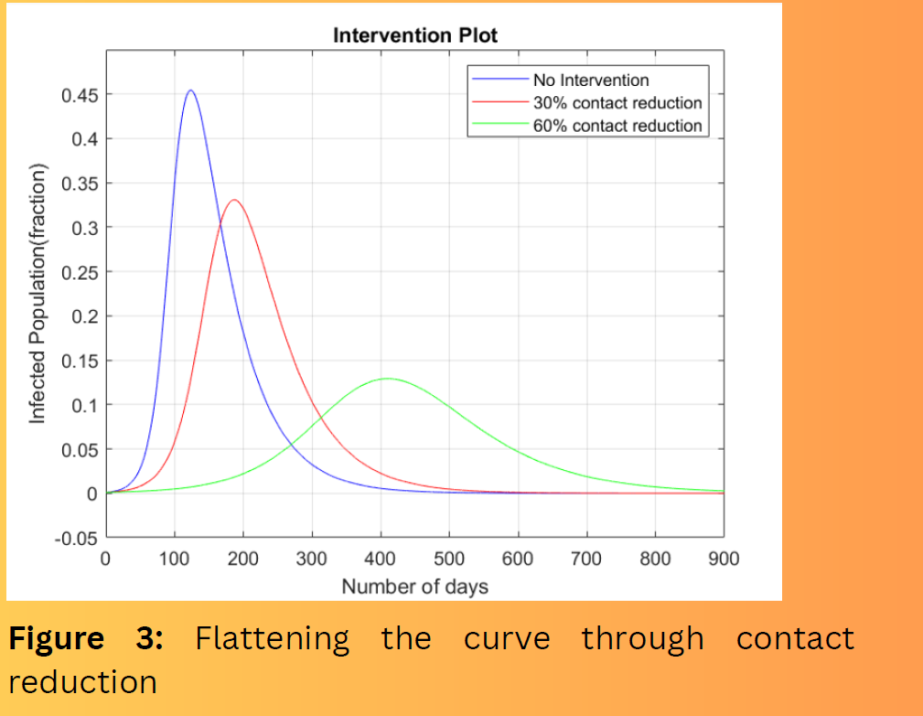

**EXIT STRATEGY**

The flattening of the curve can be adversely affected if the public and governments stop their intervention measures i.e. q = 0. It is difficult to fully eliminate a virus on a worldwide scale. The epidemic will re-emerge if the fraction of susceptible population is higher than 1/RO . The following plot depicts an example of this scenario for COVID-19.

**Exit Strategy Plot** 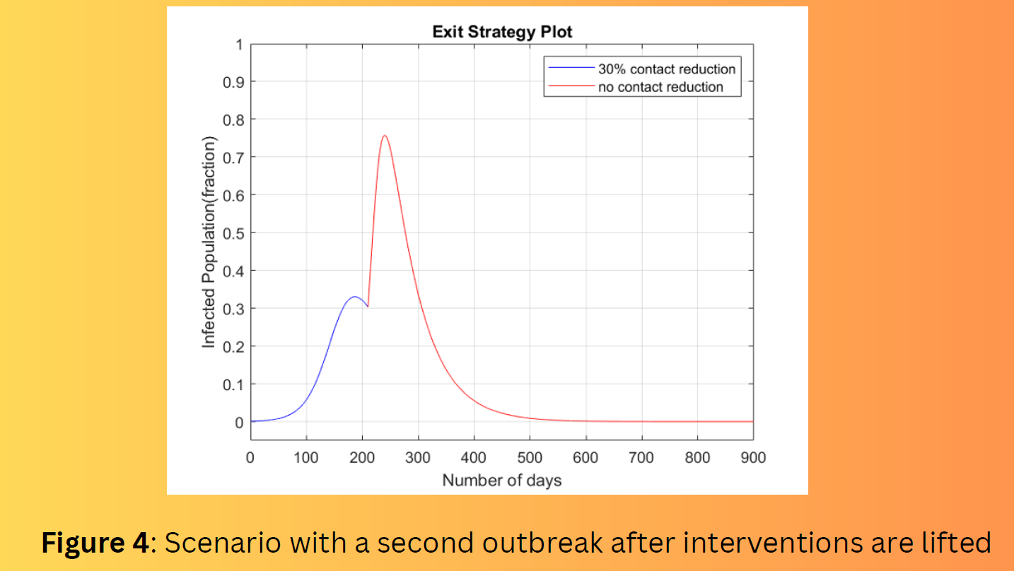

**LIMITATIONS**

* The SIR model is very basic and does not take into account many other factors. Hence many extensions of the SIR model exist like the SIR model with vaccination, the SIR model with mutation, the SIER model, the SIEARD model, etc.
* We have assumed that everyone in the population is equally likely to catch the disease which is not possible in real-world scenarios some people are more susceptible to the disease than others to the disease.
* We are not considering the incubation period for COVID-19 which can span from 5-6 days to 14 days. Considering this period would alter the analysis and outcome of the epidemic.
* The SIR model only considers a simple binary state of susceptible and recovered. It doesn't account for potential variations in immunity strength or duration, waning immunity, or reinfections.

**APPLICATION OF SIR MODEL IN CHOLERA**

Cholera remains a significant public health burden in many countries and regions of the world, highlighting the need for a deeper understanding of the mechanisms associated with its transmission, spread, and control. Mathematical modeling offers a valuable research tool to investigate cholera dynamics and explore effective intervention strategies. Cholera is an infectious disease caused by the bacterium **Vibrio cholerae** (or, V. cholerae). The main sources of the pathogen are contaminated water and food. The infection can spread rapidly in populations without safe drinking water and adequate sanitation and hygiene, and those with limited medical resources.

**BACKGROUND**

The first mathematical model for cholera dynamics was proposed by Capasso and Paveri-Fontana , based on two simple equations for the infected individuals and free-living pathogens, to study the 1973 cholera epidemic in the Mediterranean region. A notable extension from the model was made by Codeço in 2001 , where the bacterial concentration in the water supply was incorporated into an SIR model to form a combined human-environment epidemiological system. We will be analysing this model.

**EQUATIONS OF THE MODEL**

$$\frac{dS}{dt}=n\left(H-S\right)-aλ\left(B\right)S$$

$\frac{dI}{dt}=aλ\left(B\right)S-rI$

$\frac{dB}{dt}=B\left(nb-mb\right)+eI$

S(0) = H, I(0) > 0, B(0) = 0 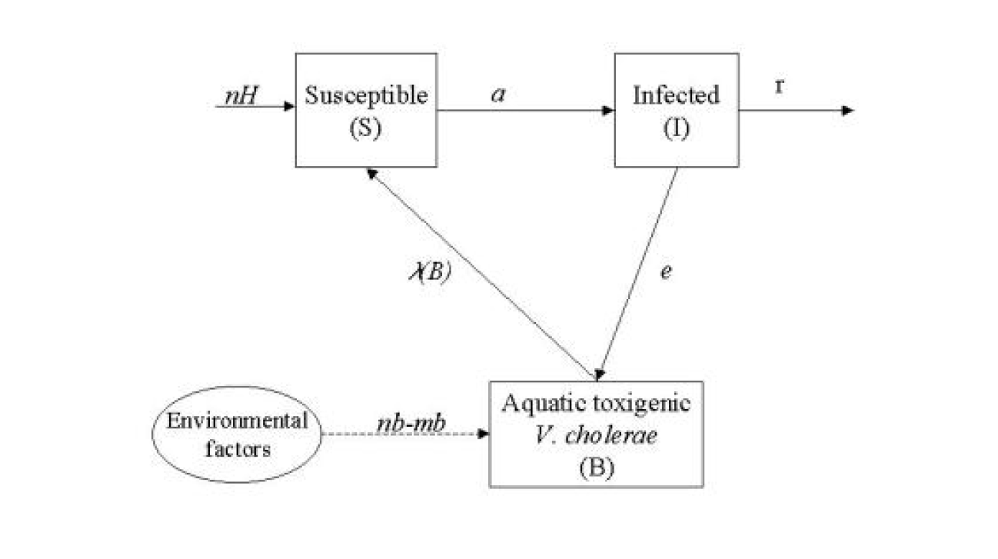

**State Variables**

S - number of susceptibles

I - number of infected

B - concentration of toxigenic V. cholerae in water (cells/ml)

**Parameters**

H - total human population

n - Human birth and death rates (day-1)

a - rate of exposure to contaminated water (day 1)

K - concentration of V. cholerae in water that yields 50% chance of catching cholera (cells/ml)

r - rate at which people recover from cholera (day-1) nb - growth rate of V. cholerae in the aquatic environment (day-1).

e - contribution of each infected person to the population of V. cholerae in the aquatic environment (cell/ml day-1 person-1)

mb - loss rate of V. cholerae in the aquatic environment (day 1)

**FIRST EQUATION**

- This equation describes the dynamics of susceptibles in a community of constant size H.

- Susceptible individuals are renewed at a rate n, which includes birth, immigration, and/or loss of acquired immunity (cholera does not confer life-long immunity).

- Susceptible individuals become infected at a rate a $λ(B)$, where:

- a is the rate of contact with untreated water.

- is the probability of such a person catching cholera.

- The probability of catching cholera depends on the concentration of *V. cholerae* in the consumed water.

- Experimental studies suggest that it is necessary to have a heavy inoculum of *V. cholerae* in order to develop cholera.

**SECOND EQUATION**

- The second equation describes the dynamics of infected people in the community, including cholera cases, asymptomatic infections, and mild infections.

- In reality, only 1 to 30% of *Vibrio cholerae* infections develop into severe cholera cases.

- Combining all infection types into a single model compartment, Codeço assumed that they follow the same dynamics.

- This assumption is reasonable if:

- Infection virulence is strongly determined by host factors (sensitivity to cholera toxin, blood type, etc.) and bacterial factors (biotype, etc.).

- These factors are not expected to change during the period of interest.

**THIRD EQUATION**

- The third equation describes the dynamics of pathogenic *Vibrio cholerae* in the aquatic reservoir, which includes untreated waters consumed by the population.

- Environmental *V. cholerae* is found in various aquatic environments such as ponds, wells, rivers, estuaries, and coastal waters.

- These environments have distinct physical, chemical, and biological characteristics.

- *V. cholerae* dynamics are likely controlled by different factors in each environment.

- Classical studies on the survival of culturable *V. cholerae* in aquatic environments suggest that *V. cholerae* cannot maintain a stable population in the environment.

The steady states of this model is

S*=H- $\frac{r}{n}$ I* and S*=H

I*= $\frac{n(kRmb-rKnb+aeH)}{e\left(n+a\right)r}$ I*=0

B*= $\frac{eI*}{mb-nb}$ B*=0

**Stability Analysis**

**J= $\left[\begin{matrix}-a-λ(B) & 0 \\ λ(B) & r\end{matrix}\right] =\left[\begin{matrix}-n & 0 \\ 0 & -r\end{matrix}\right]$**

So there will be two eigenvalues λ1 = -n and λ2=-r . It will be stable for n>0 and r>0 as λ1 and λ2 < 0

**GRAPH PLOTTING**

The code used for plotting this graph on Matplotlib is:

import numpy as np

from scipy.integrate import odeint

import matplotlib.pyplot as plt

def cholera_model(y, t, H, n, a, K, r, nb, mb, e):

S, I, B = y

dSdt = n * H - a * (B/K+B) * S - n * S

dIdt = a *(B/K+B) * S - r * I

dBdt = (nb-mb) * B + e * I

return [dSdt, dIdt, dBdt]

# Parameters

H = 10000 # Total human population

n = 0.001 # Human birth and death rates (day^-1)

a = 0.5 # Rate of exposure to contaminated water (day^-1)

K = 100000 # Concentration of V. cholerae in water that yields 50% chance of catching cholera (cells/ml)

r = 0.2 # Rate at which people recover from cholera (day^-1)

nb = 0.5 # Growth rate of V. cholerae in the aquatic environment (day^-1)

mb = 1.25 # Loss rate of V. cholerae in the aquatic environment (day^-1)

e = 5 # Contribution of each infected person to the population of V. cholerae in the aquatic environment (cell/ml day^-1 person^-1)

# Initial conditions

S0 = 10000 # Initial number of susceptibles

I0 = 0 # Initial number of infected

B0 = 100 # Initial concentration of V. cholerae in water (cells/ml)

y0 = [S0, I0, B0]

# Time vector

t = np.linspace(0, 100, 100)

# Solving ODE

solution = odeint(cholera_model, y0, t, args=(H, n, a, K, r, nb, mb, e))

S, I, B = solution.T

# Plotting

plt.figure(figsize=(10, 6))

plt.plot(t, S, 'b', label='Susceptible')

plt.plot(t, I, 'r', label='Infected')

plt.plot(t, B/10, 'g', label='Concentration of V. cholerae in water')

plt.xlabel('Time (days)')

plt.ylabel('Population/Concentration(')

plt.title('Cholera Model Simulation')

plt.legend()

plt.grid(True)

plt.show()

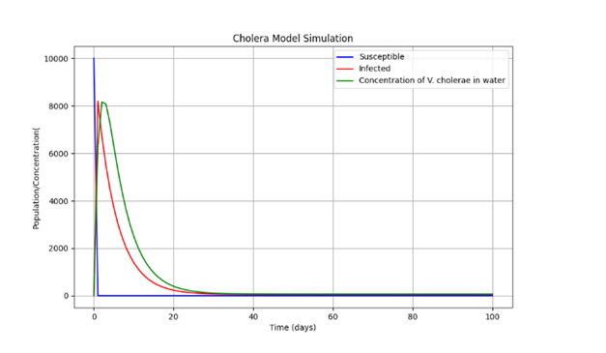

By changing the value of ‘e’ from 10 to 5 and ‘r’ from 0.2 to 0.05

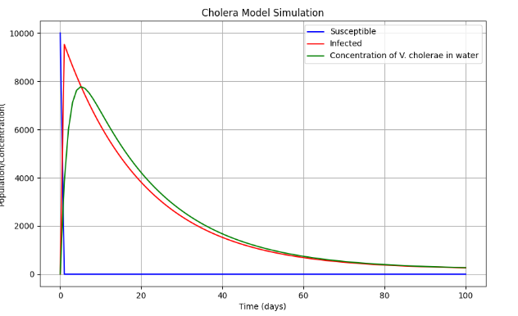

By changing the value of ‘a’ from 0.5 to 0.1 and ‘mb’ from 1 to 1.25

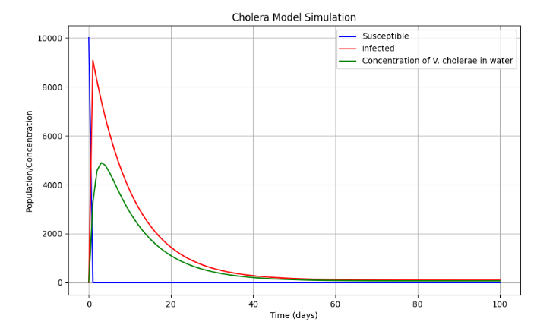

These graphs highlight the variation of different parameters to the shape of the curve and respective changes in the values of susceptible, infected and V. cholerae population.

We have assumed the death rate of V. cholerae to be greater than the birth rate as V. cholerae is a bacterium that predominantly resides in aquatic environments, especially in estuarine and marine environments. These environments can be harsh, with fluctuating temperatures, salinity, and nutrient availability. V. cholerae has a relatively short survival time outside the human host. While it can survive for a certain period in water and on surfaces, its survival is limited compared to other bacteria.

**Future Advantages**: Models provide the advantage of examining several possible outcomes at once as opposed to just one prediction. In the past, models have demonstrated varying degrees of dependability during pandemics including SARS, SARS-CoV-2, swine flu, MERS, and Ebola.

**CONCLUSION**

The SIR model examines not only the time dependent equations but also derived the different variable relationships to one another. Specifically, this study derived the equation for the number of infected cases depending on the number of susceptible individuals, which in turn was found with respect to removed individuals. These equations allow for the study of infection in relation to transmission. From these we are able to further predict the growth of epidemics and pandemics and devise strategies to prevent any loss of life.

**REFERENCES**

[Endemic and epidemic dynamics of cholera: the role of the aquatic reservoir - PMC (nih.gov)](https://www.ncbi.nlm.nih.gov/pmc/articles/PMC29087/)

HTTPS://MAA.ORG/PRESS/PERIODICALS/LO CI/JOMA/THE-SIR-MODEL-FOR-SPREAD-OFDISEASE-THE-DIFFERENTIAL-EQUATIONMODEL

<HTTPS://WWW.NCBI.NLM.NIH.GOV/PMC/AR>TICLES/PMC7321055/#:~:TEXT=THE%20SIR%2 0MODEL%20CAN%20BE,INDIVIDUALS%2C%20 NO%20SERIES%20IMPACTS%20OCCUR